
EGERTON UNIVERSITY

FACULTY OF SCIENCE
DEPARTMENT OF COMPUTER SCIENCE

COMP 390
GROUP PROJECT
DAIRY FARM MANAGEMENT SYSTEM
SUPERVISOR: DR.BOSIRE

GROUP MEMBERS
Name | Registration number
Godwill Trevor Kisia | S13/03118/18
Emmanuel Kalabai Wamalwa | S13/03160/18
Anthonate Barsai Jeptoo | S13/03177/18
Susan Olayo Washika | S13/03152/18
Betty Mbulwa Mutunga | S13/03132/18

SOFTWARE REQUIREMENT SPECIFICATION
Introduction
The dairy farm management system is a technology that is aimed to automate the process of record keeping .This will help dairy farmers to mitigate losses like food, wastage and increase dairy farm productivity.
Purpose
The expectation of the dairy management system is to automate the dairy farm record keeping practices.
Scope
The users of the system will include;
- System admins
- Unregistered customers
- Registered customers
This is the collection of all activities in the dairy farms and to what extend the dairy management system will cover.
Functional requirements
The system shall allow customers to register
The system shall allow customers to login into the system
The system shall allow administrator to login into the system.
The system shall allow admin to key in data based on their privileges
The system shall generate reports upon administrator request .h
Non- functional requirements
The system shall be implemented using python
Downtime shall not exceed one minute
The system shall not disclose customer’s confidential information
The database used should be postgres.
The system shall support multiple users without failure
The system can operate on any operating system
The system is secure with the ability of keeping safe the user’s information.
The system shall be easy to learn and use.
Safety and security requirements
The user to supply the username and password before login for authentication.Various users of the system are given various privileges that they can perform once logged into the system e.g only super admin can register admins
The customers and admins passwords will be encrypted

USE CASE DIAGRAM
Registered customer
Super admin
Admin
Unregistered customer
Register admin
Login
View products available
Update
Key in data
Generate reports
Login
Reset password
Make order
Help
Login

Register
Dairy Management system

<<Extend>>

<<include>>>>
<<extend>>

<<Include>>

Response to order request

Q`1USE CASE DESCRIPTION
1. Change password
Use case name | Change password
Goal | Change password
Use case ID | DM001
Actors | Registered customer
Pre-conditions | The customer must be registered into the system and have login credentials
Primary course | Customer starts the session.  Customer log in to the system  System verify the credentials  The system gives the customer a page where the customer can change password  The customer clicks on change password button and gets a pop up where the customer fills the old password, new password, confirm new password fields and submits  The system validates and saves the changes, it then returns success.
Alternative course | The customer provides wrong old password, the system prompts the customer to fill correct details  The customer provides new password and confirms the new password that matches  The new password is saved in the database
Exceptional course | None
2. Buy cow(s)
Use case name | Buy cow(s)
Goal | Buy cow(s)
Use case ID | DM002
Actors | Registered customer
Pre-conditions | The customer must be registered and have loin credentials
Primary course | Customer starts the session  The system requests the customer to log in  Customer logs into the system  The system authenticates the customer  The system then returns a dashboard page that the user can click on and view cows that are available for sale  After clicking the buy cow button, the customer is prompted to make payment by the system  The customer makes payment and enters transaction code into the system  The system verifies payment and returns success  The system gives the customer information on how to collect the purchased cow.
Alternative course | The customer provides wrong transaction code  The system prompts the customer to provide3 a valid transaction code.
Exceptional course | None

3. Order milk
Use case name | Order milk
Goal | Order milk
Use case ID | DM003
Actors | Registered customer
Pre-conditions | Customer must be registered into the system and have login credentials
Primary course | The customer starts the session  The customer logs in and is authenticated by the system  On the customer’s dashboard, the customer clicks the order milk button.  A pop up requesting the customer to enter the amount of milk to be purchased pops up.  The system calculates the total amount and request the customer to make payment.  The customer enters a transaction code and submits  The payment is verified by the system, processes the order and returns successful with a description of how to collect the ordered milk.
Alternative course | The customer provides wrong transaction code, the system requests the customer to enter valid transaction code.
Exceptional course | None

4. Respond to milk order request
Use case name | Respond to milk order request
Goal | Respond to milk order from customers
Use case ID | DM004
Actors | Milk sale admin
Precondition | Must be an admin
Primary course | The milk sale admin initiates the process by visiting the website.  The milk sale admin enters username and password.  The system verify the username and password .After the verification the milk sale admin he/she login to the system.  The milk sale admin updates the record the record on the milk collected.  The admin then checks the notification from the customer on the transaction code, the phone number and the amount that the customer has paid.  The milk sale admin enters into the system the transaction code, phone number and the amount paid by the customer for milk.  The admin by the use of the system sends a notification message to the customer that the order has been placed successfully
Alternative course | In case a customer sends less or more amount than what he/she was supposed to pay for milk, the milk sale admin returns the extra amount to the customer, and for underpay the admin notifies the customer to add on the amount.
Exeptional course | None

5. Update customer details
Use case name | Update customer details
Goal | Update customer personal information
Use case ID | DM005
Actors | Registered customer
Pre-conditions | The customer must be a registered customer and have valid log in credentials
Primary course | The customer starts the session  The customer logs in and is authenticated by the system  On the customer’s dashboard, the customer clicks the update details button.  A pop up for the customer to update his or hers personal information appears. The customer feeds the data and saves.  The system processes the information and saves in the system.
Alternative course | None
Exceptional course | None

6. Login
Use case name | Update record
Goal | Update record
Use case ID | DM007
Actors | System admin
Pre-conditions | Must be registered by the super admin and have log in credentials
Primary course | Admin access the website of the system and starts the session  Admin logs into the system and is authenticated by the system  Admin is directed to the admin dashboard page where he or she selects update record button  Admin is allowed to update the records in any field  Admin saves the changes and are updated in the database.  The system returns success
Alternative course | The admin is asked by the system to fill all required fields if the admin fails to fill all fields
Exceptional course | None

Use case name | Login
Goal | Access main menu
Use case ID | DM006
Actors | Customer
Pre-conditions | Customer must have a registered account
Primary course | Customer starts the session  The system requests the customer to enter login credentials  Customer provides login credentials and submits  The system validates credentials and allows the customer to access main menu  The customer is logged into the system
Alternative course | In case of entry of invalid credentials ,the customer is prompted to renter  In case the customer has forgotten password, he or she is requested to reset the password.
Exceptional course | None

7. Update record

Use case name | View
Goal | View available cows
Use case ID | DM008
Actors | Customers
Pre-conditions | Customer must start a session
Primary course | The customer accesses the system and views available cows
Alternative course | None
Exceptional course | None
8. View

Use-case name | Add admins
Goal | Add admins
Use case ID | DM009
Actors | Super admin
Preconditions | Must be a super admin, has login credentials
Primary course | The super admin starts the session.  The super admin logs into the system.  The system returns the welcome page.  The super admin selects the add admin button.  The system returns add new admins page.  The super admin enters the new admins credentials and clicks submit.  The system checks against the database and returns success.  The system ends the process.
Alternative flow 1 | The super admin fails to fill all the required field.  The system rejects the record with an error message, ‘please fill all the required filed’.
Alternative flow 2 | The super admin enters details that already exists in the database.  The system rejects the record with an error message, ‘the admin already exists’.
Exceptional course | None

10. Generate reports
Use case name | Generate reports
Goal | Generate reports
Use case ID | DM010
actors | Super admin
Precondition | Must have logged in and has super admin credentials
Primary course | The super admin starts the session  The super admin logs in to the system  The super admin selects the generate report button  The system prompts the super admin to enter the record to generate report  The system then generate report
Alternative course | None
Exceptional course | None

11. Update admin details
Use case name | Update details
Use case goal | Update details
Use case ID | DM011
Actors | Super admin
pre-condition | Must be an admin and has have login credentials
Primary cause | The super admin starts the session  the super admins logs in to the system  The super admin clicks on the view admins button  The system returns all the admins with button to update admin details.  The super admin selects the update button against the admins he/she wants to update.  The system returns a pop up with the targeted admins credentials.  The super admin updates the fields he/she wants to update and submits.  The system effect the changes and flashes success.
Alternatives flows | The super admin leaves the required fields blank the system prompts with an error that all fields must be filled
Exceptional cause | None

12. Enter records
Use case name | Enter records
Goal | Enter records
Use case ID | DM012
Preconditions | Must be an admin and have login credentials.
Primary course | The admin initiates the session and logs into the system.  The system redirect admin to welcome page.  The admin selects the add record button  The system returns the enter new record page according to the privileges on the system  The admin fills in the required fields in the form and submit the form  The system effects the process and updates the database  The system then returns success message  The system ends the process of entering records.
Alternative cause | The admin fails to fill all the required fields, the system rejects the record and return error message “please fill all required fields” and the system terminates the process
Exceptional cause | None
Software Design Document
Introduction
The dairy farm management system is a technology that is aimed to automate the process of record keeping .This will help dairy farmers to mitigate losses like food, wastage and increase dairy farm productivity.

Scope
The users of the system will include;
- Administrators
- Registered customers
- Unregistered customers

Purpose
The expectation of the dairy management system is to automate the dairy farm record keeping practices.

Constraints
Python programming language for developing the system is considered.
The downtime when using the system should not exceed one minute.
It should be able to operate on different platforms or operating systems such as windows, Linux.
Every user must provide a user name and password for authentication while login into the system.
Use of specific framework for database development.
Different privileges to the customers, admins and super admin;
- Only the super admin who can register the admins.
- Only super admin can generate all reports
One must have an internet connection to use the system.
The dairy farm management system should have an operational license.

User interface Designs
Customer homepage
Photos
Animal View
HOME
User Register
Admin login
User Login

Welcome to Dairy Farm Management Website

Brief Description

Contact us
Social media icons
Customer registration page
SUBMIT

First name

Last name

Username

ID Number

Password

Confirm password

Email

Phone number

USER REGISTRATION FORM

Customer login page
Login
Username

Password

Forgot password? Click here.

Customer login

Customer Dashboard
See images of cows available for sale.
SAVE
Old password

New Password

Confirm Password

POPUP
SAVE
Firstname

Lastname

Email

Phone number

POPUP
POPUP
SUBMIT
Amount in litres

Total amount

Transaction id

POPUP
Change password
Order milk
View cows on sale
Update personal information
Welcome Betty

Photos of available cows view page

Filter by
HOME

Username

Password

Gets back to register page
POPUP
BUY
Details
Price
Photos

Super admin log in page
Login

Admins operational page

Customer view
Admin view
……………………………………..POP UPS ………………………………………………
Update
Change password
Print
Register admin

Admin login page

Username

Password

Forgot password? Click here.

LOGIN

Admin Registration page

ID Number

First name

Last name

Other names

Phone number

Email

Staff ID

User name

Password

Confirm Password

Role
Admin Registration page
SUBMIT

Admin Dashboard
View cows
View Records
View customers
Print
Update Records
Enter Records

Inventory links
HOME
Feeds inventory link
Cows feed link
Enter New Records

Cows feed form
SAVE

Type of food

Quantity

Time of feeding

Cow’s tag ID

COWS FEED FORM
HOME

Feed’s inventory
FEED’S INVENTORY
SAVE

HOME

Type of food

Quantity available

Supplier name

Supplier phone number

Human –Machine interface
Inputs
The Dairy farm management System accepts all its inputs through text files. All the necessary data is captured from the customer and securely stored to the database so that it can be used later throughout the system. Before data storage, all the data is validated to ensure that users do not submit some empty fields or data with errors. Error messages will be displayed so that users will be able to identify where they make mistakes so that they can correct.
- The data types for different field are defined such as text, date, number or email so that the user inputs the correct data type. Some fields are unique since they only belong to a particular record and the system ensures that this is catered for.
- User sensitive information such as passwords will be encrypted so that hackers and other computer professionals with malicious or bad intentions are not able to capture such data from the database easily.
- For security purposes, only the users who are authenticated by the system will be able to input other.
Outputs
The expected outputs of the dairy farm management system;-
Generation of reports for the dairy farm
Keeping of updated data
Keeping track of all records generated by any activity in the dairy farm.
Hardware detailed design
The Dairy Farm management System being web based it only requires a few hardware components to ensure that it is useful to the clients. It requires a device which is a computer, either personal, desktop or hand devices such as mobile phones so that it can be used.
The personal computer used to access the system requires that each have a browser, which can either be Mozilla, Google, Chrome, internet explorer and safari.
It also requires a server where the user data can be stored for easy accessibility over the internet. This is a high-speed server that can handle multiple requests from different users at the same time. The server should have a minimum of the following details:
- 8GB RAM (Random Access Memory)
- 1TB hard disk.
- Continuous power supply to ensure that services are available all through.

Software detailed design
The system will contain several modules to ensure its full functional as expected. These modules and their functionality are as follows:
Customer login
This module handles customer registration and log into the system. The customer is able to view available cows for sale, make orders for buying cows and order milk.
Users register and logs in using their credentials.
Admin Login
This module facilitates the admins to be able to register and log into the system. The admins are able to respond to customer requests, key in data, update data and generate reports. Only the admins who log in successfully are able to use the system. Only the super admin who can register the admins.
Internal communication detailed design
The communication process of the Dairy management System will be achieved by internet which will enable communication between the system and the database during user data storage and retrieval of the required data by the user and communication between the different modules of the system. A web browser will be used as an interface in order to make requests to the web server and also to render the response back the user for the requested resource. HTTP (Hyper Text Transfer Protocol) is used to ensure communication between the web server and the web browser.

DATABASE DESIGN
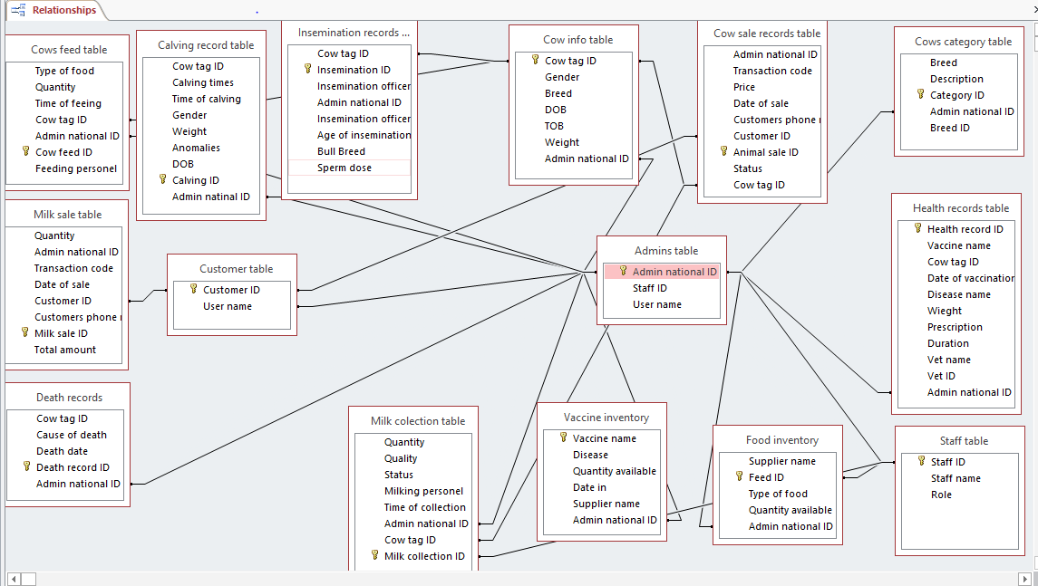

System architecture
Client server
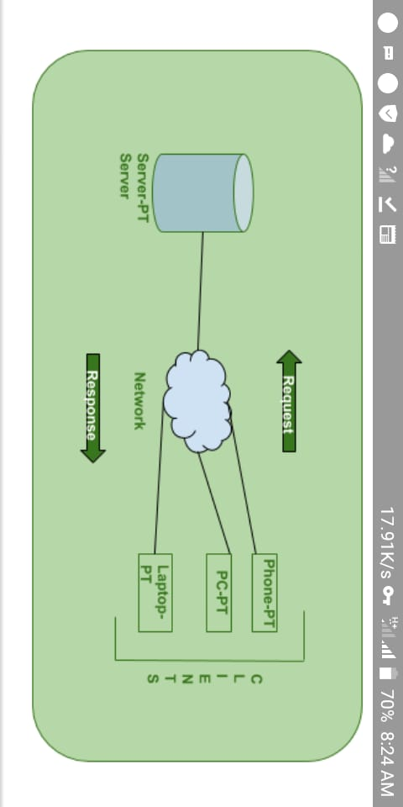
System integrity controls
Only the authorized admins will be allowed to enter and modify the content of the database .They are required to have validated username and password for authentication.
The customers are also allowed into the system only after providing valid username and password.

Activity Diagrams
Admin activity diagram

Enter credentials

Validate
Reset
No
Send reset notification

Yes
Enter/ update records
Generate report
View cows/View users

Customer registration Activity diagram
Successful
Failed
Yes
Validate
Yes
Enter new password
Confirm new password
No
Yes
Validate
Provide username and Phone number
Order milk/View cows/ Buy cow
Yes
No
Validate
Enter login credentials
No
Validate
Enter credentials

Super admin activity diagram
Generate report/view users/view admins /Register admins/Reset admins passwords /view cows
No
Yes
Validate credentials
Enter credentials

Data flow diagram
Generate reports
Dairy Farm management system
Super admin login
Admin login
Customer buy cows
Customer order milk
Customer registration
Admin update records
Admin enter records

